a) Explain with examples Linear and Non-linear data structures.
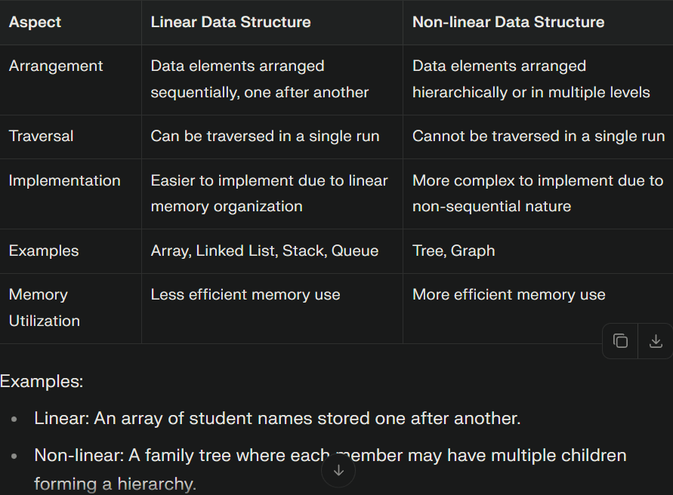

b) Define and explain the asymptotic notations Big "O" and Theta (0)
1.Big oh (O) notation : Asymptotic "less than"(slower rate).This notation
mainly represent upper bound of algorithm run time.
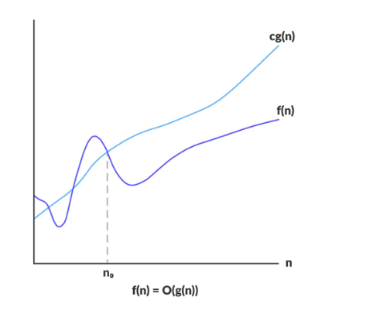
Big oh (O)notation is useful to calculate maximum amount of time of
execution.
By using Big-oh notation we have to calculate worst case time complexity.
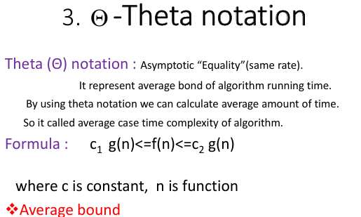
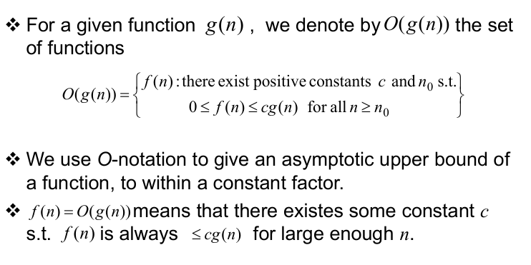

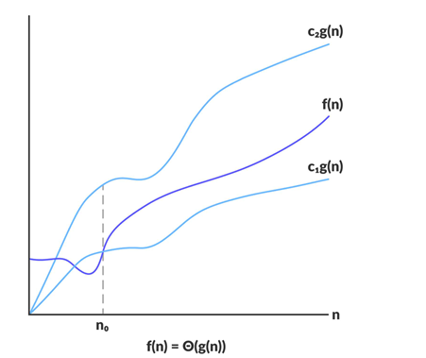

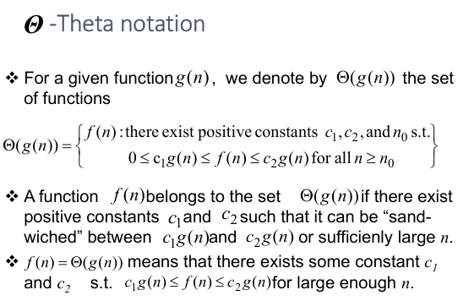c) Explain array representation of a binary tree with suitable example.
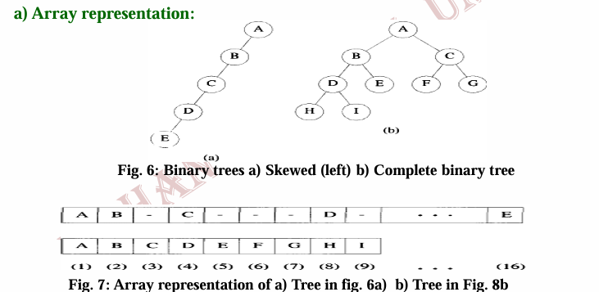

d) Write a detailed note on Threaded Binary Tree.
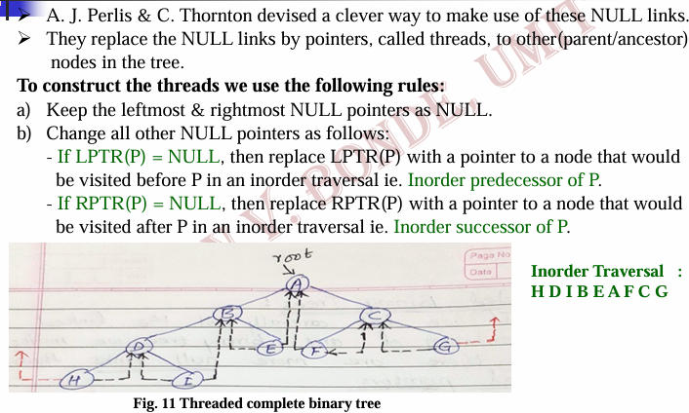
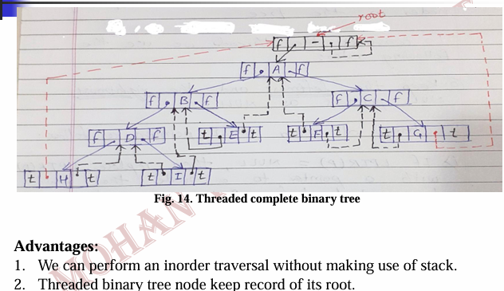
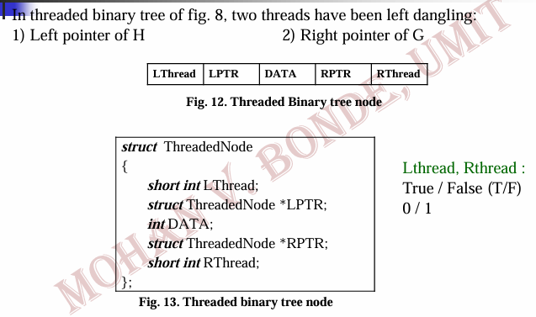
Q2. a) Write general rules for conversion of infix to suffix expression, Also convert the following infix expression to suffix by applying these rules. a + b*c-d/c*h
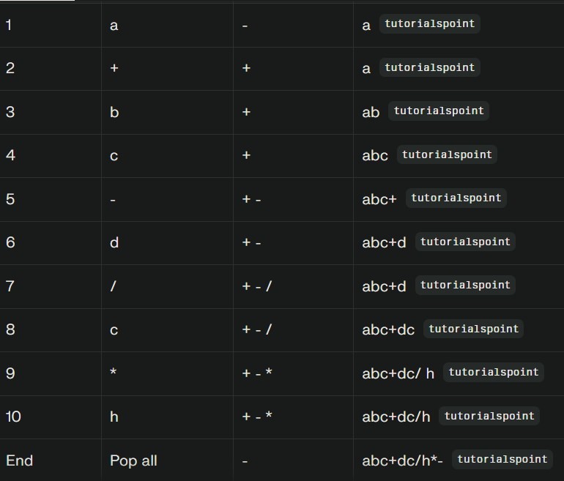b) Write an algorithm to insert an element into the circular queue.
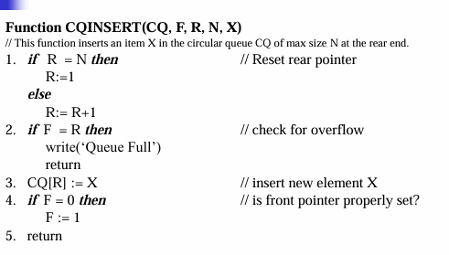
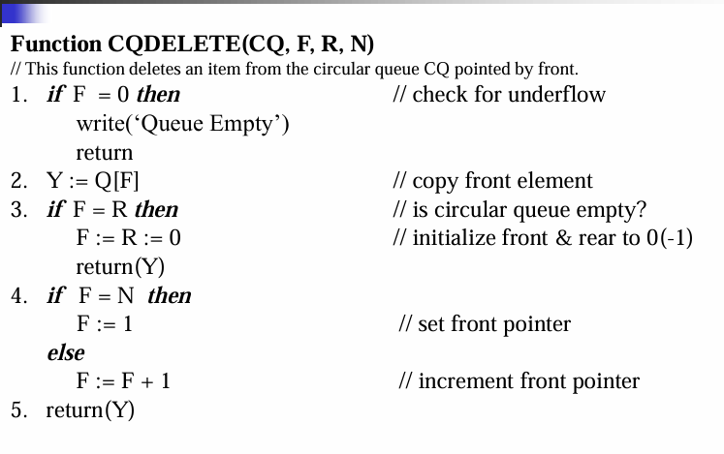
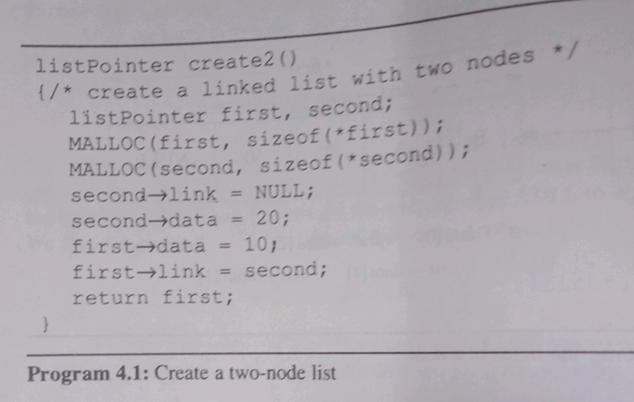
Q3. a) Define linked list. Also write an algorithm to insert an element in single linked list
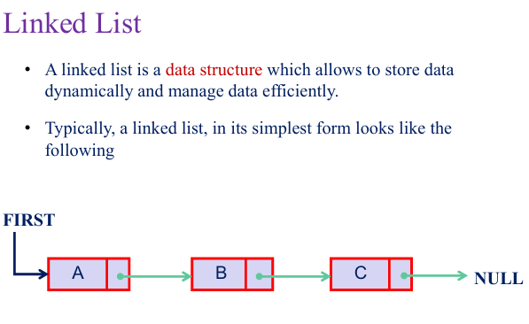
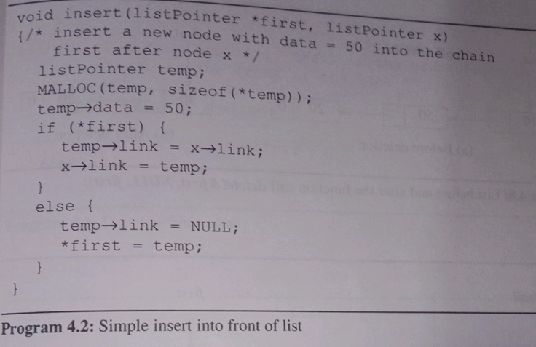
Q4. a) Write an algorithm for Selection Sep Also sort the following set of elements using selection sort procedure and not otherwise.42, 23, 74, 11, 65, 58, 94, 36, 99, 87
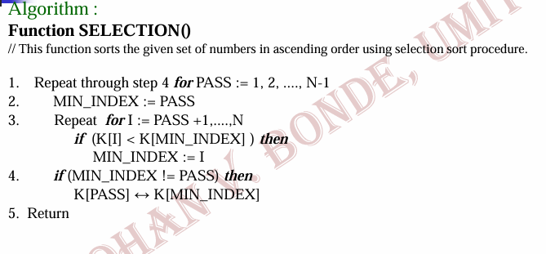
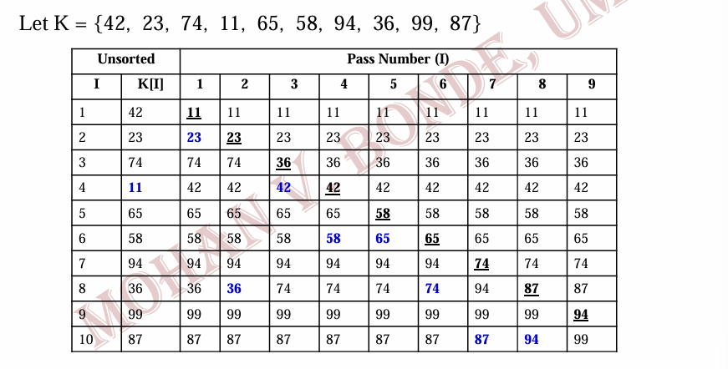
b) Define Heap. Construct the max-heap for the following numbers.44, 30, 50, 22, 60, 55, 77, 55
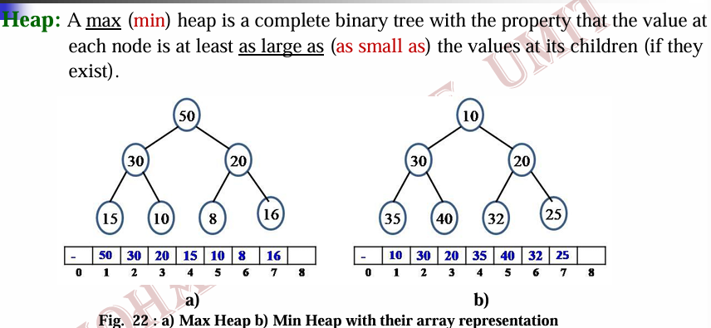
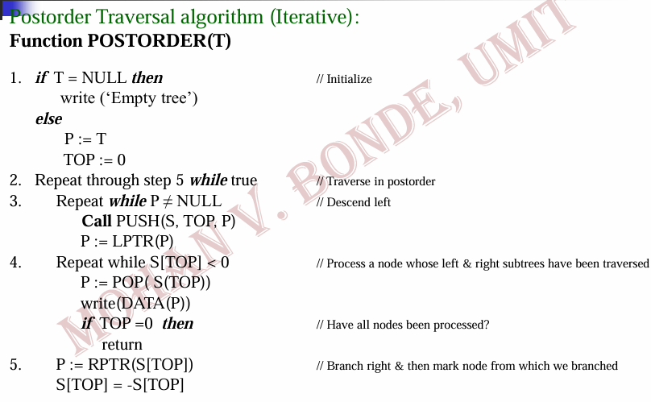
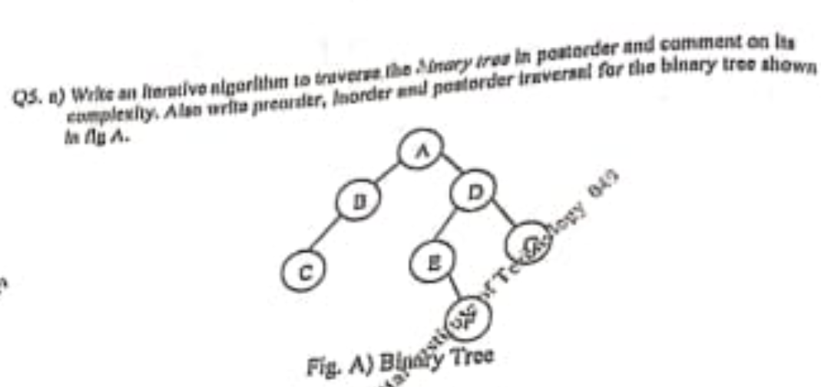


b) Write the difference between tree end Binary tree.

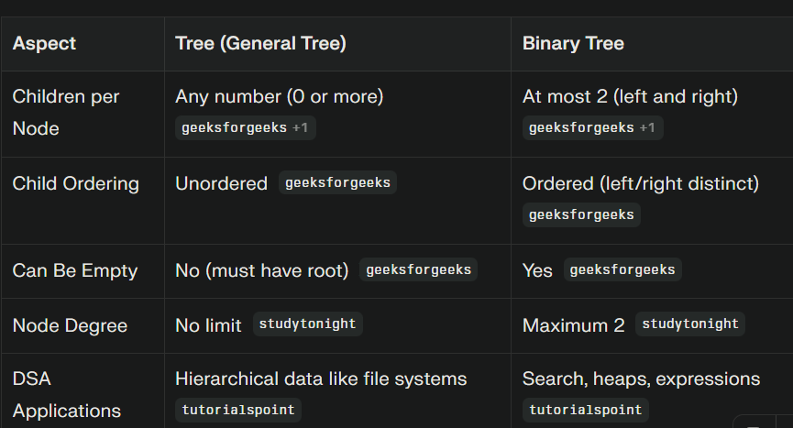

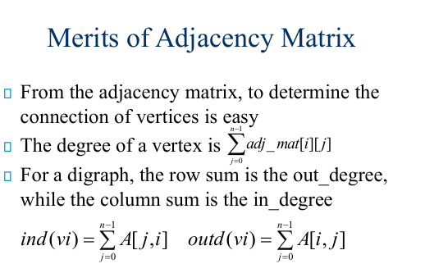
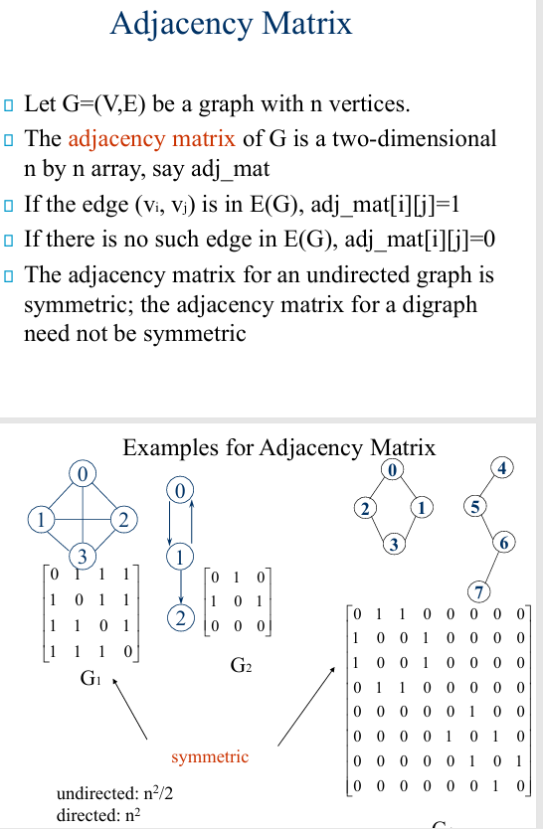
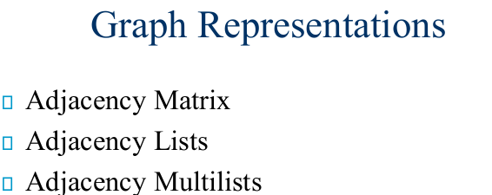
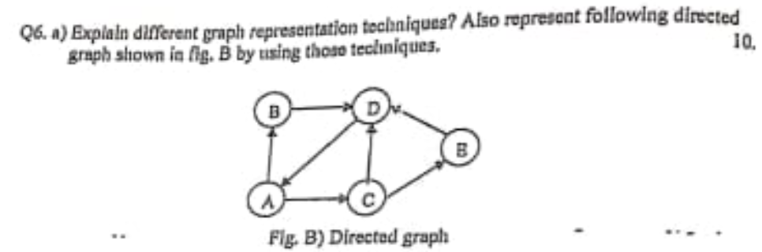
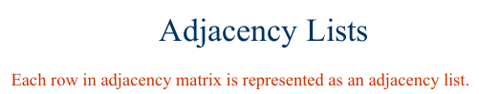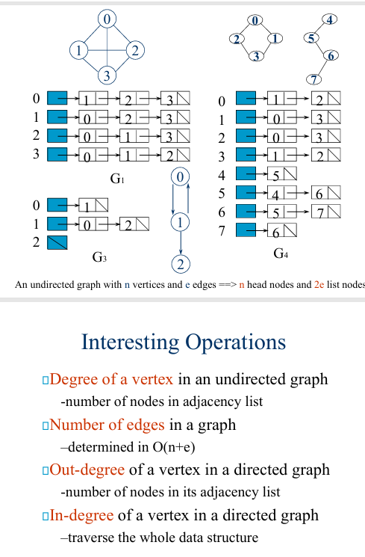

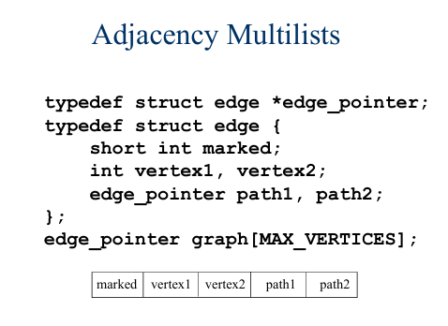
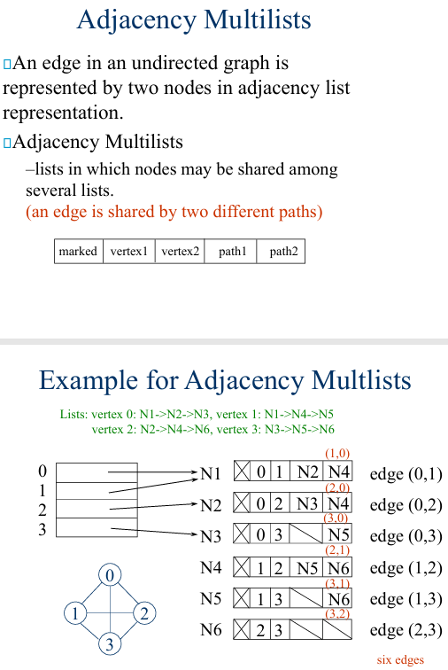

b) Write an algorithm to search the graph in Breadth First search (BFS) manner
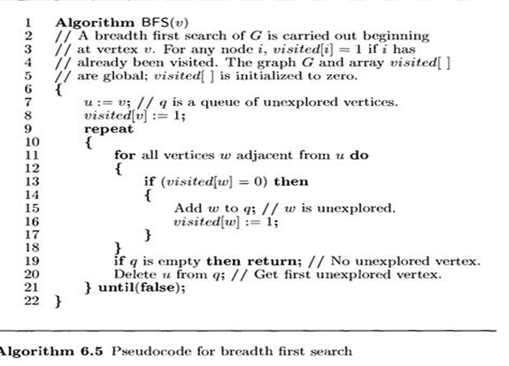
Q7.a) What is Hashing? Explain Division/Modulo method of Hashing. Also store the following numbers using the said method in the Hash tnble.8 3 6 10 15 9 4 25
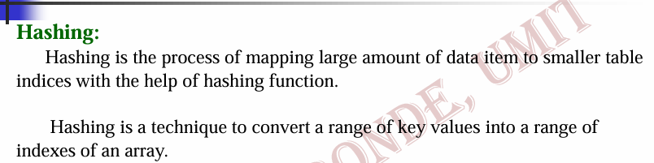
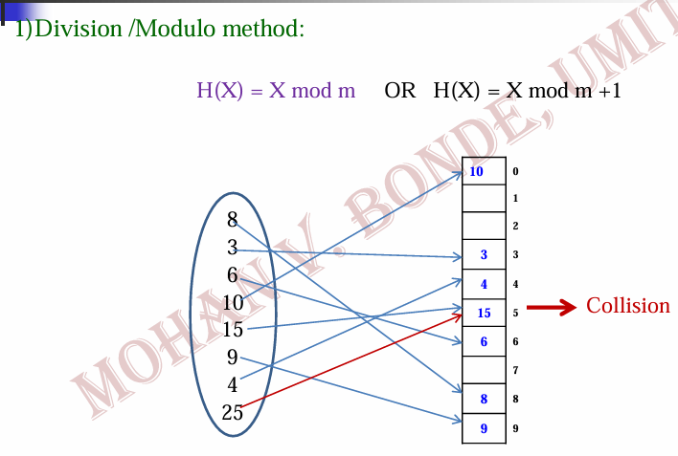

b) Write a recursive algorithm for Binary search along with its time complexity.
